OUCH!
GLASS VERSUS FLESH - GLASS WINS EVERY TIME
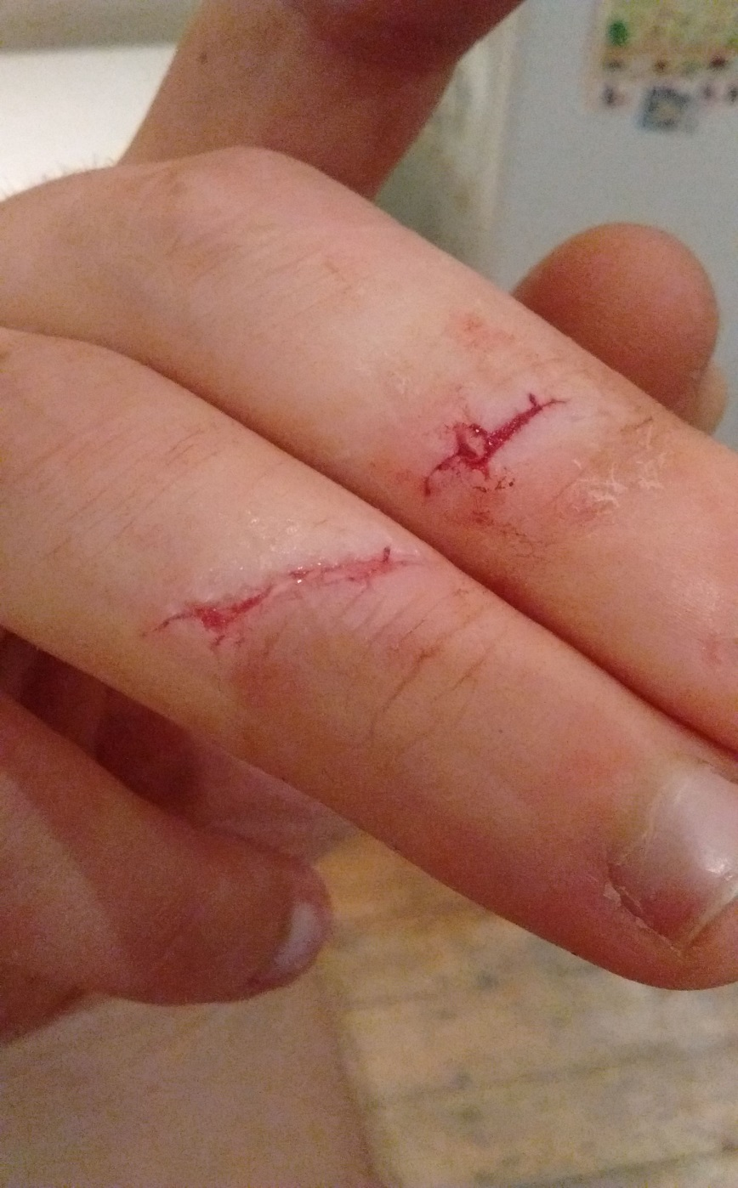

CHECK LABORATORY GLASSWARE BEFORE YOU USE IT. IF YOU FIND CHIPS OR CRACKS: GET FIXED OR GET RID.

