CHEMICAL CONTAMINATION!
YOU HAVE SECONDS TO ACT! SO ACT NOW!
APPLY DIPHOTERINE AT ONCE.
SPRAYS AND EYEWASHES ARE CONTAINED IN ORANGE HOLDERS IN LABORATORIES.
NO SPECIALIST TRAINING REQUIRED – ADMINISTER TO SELF OR TO COLLEAGUE.
USE THE WHOLE CONTAINER.
DIPHOTERINE NEUTRALISES CHEMICALS MUCH FASTER THAN WATER.
THEN CALL A FIRST AIDER.

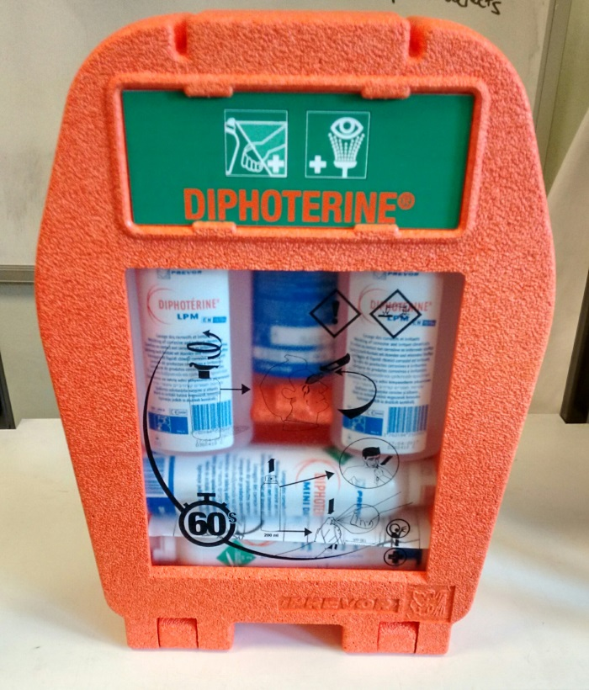

(NOT FOR USE WITH HF OR THERMAL BURNS).

